# Alloy 8 Demo Site

*Updated to latest 8x versions available as of September 1, 2015*

## Disclaimer

* Completely unsupported. ☺ However, a great starting point. If anything is unclear Google is your best friend.

## Add-ons

* Google Analytics
* SiteAttention SEO
* Social Reach
* PowerSlice
* Projects
* Content Collaboration
* Languages
* Find
* MenuPin
* Carousel
* RSS Reader
* Blog
* Tree Icons
* Live Monitor
* Styles Properties
* SocialFeedBlock to show Twitter, LinkedIn, Facebook feeds
* Apple Watch Display Channel
* **NEW – Disable Indexing job**
* **NEW – Geta SEO Sitemaps**
* **NEW – Possible Robots.txt Handler**
* More!?

Note: The Silverpop connector has been removed. Due to known problem trying to install another connector, it was deemed easier to have no Marketing Automation connectors and let the developer decide which one they wanted to install.

## Configs

* Personalized Dashboards and workspace in the editorial interface for all users
* Various visitor groups
  + Both “Interested in Alloy Track” and “Interested in Newsletter” have personalized content on home page and are category based so viewing the right content 1-2 times will show personalization in effect with ease.
  + Others as well
* Limited pages available below “News Page” type
  + Try creating a page under “Press releases”
* Several additional languages and fallbacks for each non-English
* SITE TEMPLATES area with second skeleton site and various configs to make your life better
  + Great for personalized customer demos
* Workflows
  + Setting a page as “Ready to Publish” under Press Releases will kick off a workflow for approval by Administrators or ContentEditors (e.g. epiadmin)
  + Additional workflow configs also enabled for pages under Products
  + Note, may not work for Azure Websites
* Content collaboration conversations between epiadmin and nancy if you select About Us~News and Events~Press Releases
* Simple Alloy Track Mobile Campaign in Projects
* Additional forms
* Additional categories that are applied to various pages
* Office Locations page with fake Google Map (99.9999% of people will never ask)
  + Note, there are blocks available if you want the real item
* Many other general content changes and improvements
* Referral from Twitter Visitor Group
* Twitter feed block shown on home page for visitors referred from Twitter
* PowerSlice moved to left hand side of page for all users
* **NEW - Geta SEO Sitemaps and Possible Robots.txt CMS Admin configurations**
* **NEW - Disabled Indexing scheduled job to disable all pages being indexed**
* Change to the second sites URL in administration interface.
  + See Basic Setup instructions below.
* Many more!

## Basic Setup

* Set up all System Requirements
  + <http://world.episerver.com/documentation/Items/System-Requirements/System-Requirements---EPiServer/>
* Set up your own Find index and update web.config accordingly (Alloy Demo Kit won’t run unless this is in place)
  + <http://find.episerver.com/>
* Obtain and add a new license to the root directory
  + <http://license.episerver.com>
* If you want to IIS for the web server follow the steps below. Otherwise if using VS skip ahead to the next major bullet
  + Change the root folder access security settings to allow IUSR and IIS_IUSRS access
  + Create a new site in IIS and point it at the root folder location
    - Set up a site binding and related URL
      * Ensure you have a site binding entry that catches all other incoming to that domain

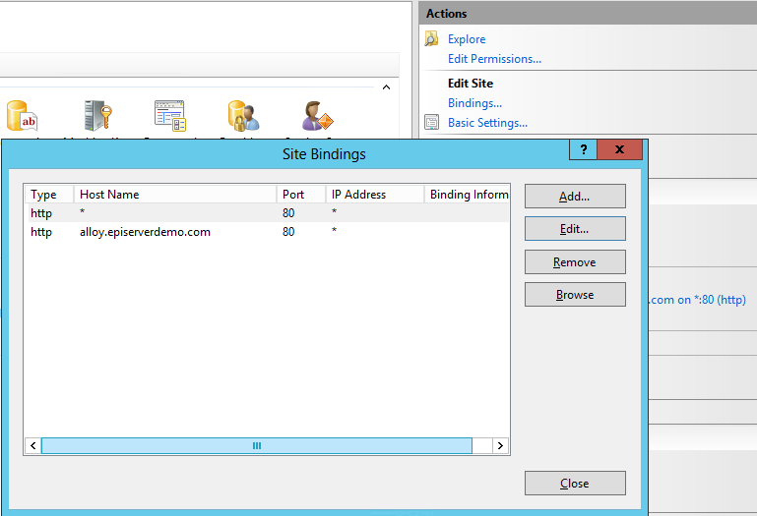

* + - Add a similar entry to your hosts file if you want to fake the DNS
      * <http://www.howtogeek.com/howto/27350/beginner-geek-how-to-edit-your-hosts-file/>
  + Update setting in the administration interface under Config~Manage Websites. Update both sites!
    - For example,
      * alloy.com
      * microsite.alloy.com

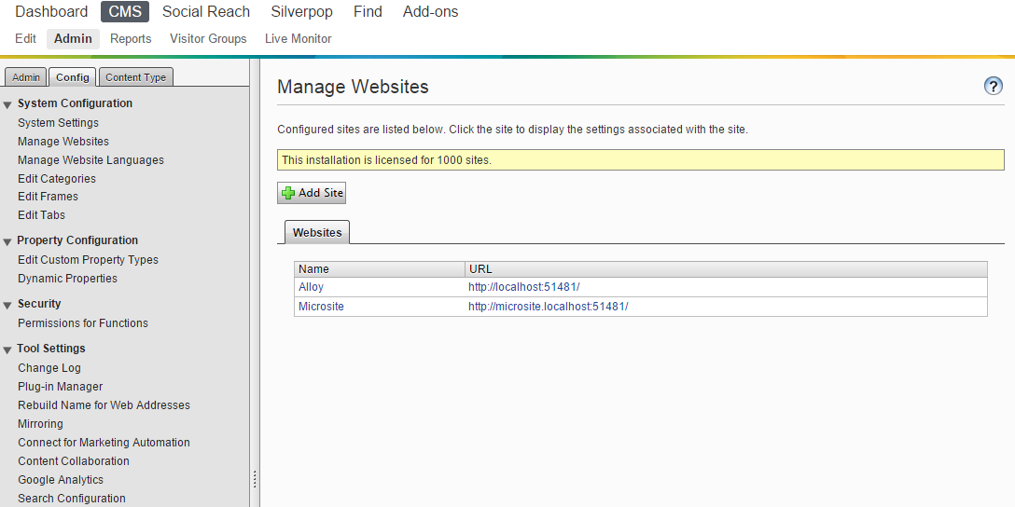

* + Navigate to the Application Pools in IIS, select the app pool you just created, and change “Load User Profile” to true

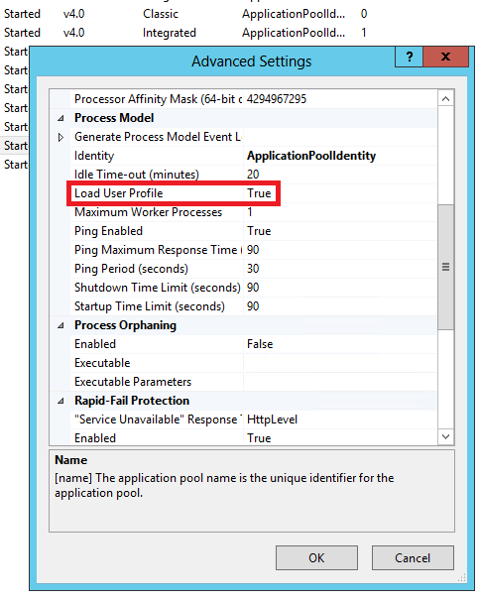

* + Additional info and options for why/how:
    - <http://blogs.msdn.com/b/sqlexpress/archive/2011/12/09/using-localdb-with-full-iis-part-1-user-profile.aspx>
* Configure Google Analytics account
* Configure Social Reach account(s)
* Optionally…
  + If you want the LanguageManager to work you need to set up your own related Bing or Google developer account and update the config at:
    - \modules\_protected\EPiServer.Labs.LanguageManager\ EPiServer.LanguageManager.config
    - Additional info: <http://world.episerver.com/add-ons/episerver-languages/configuring-auto-translation/>
  + **NEW - To make the second site available in IIS Express so that when you select the URL is loads as expected:**
    - Open %USERPROFILE%\Documents\IISExpress\config\applicationhost.config in a text editor. Find the entry similar to the following:

<site name="EPiServerSite2" id="14">

<application path="/" applicationPool="Clr4IntegratedAppPool">

<virtualDirectory path="/" physicalPath="C:\EPiServer\AlloyDemoKit\src\AlloyDemoKit" />

</application>

<bindings>

<binding protocol="http" bindingInformation="*:51481:localhost" />

<binding protocol="http" bindingInformation="*:51482:localhost" />

</bindings>

</site>

* + - And add the second binding highlighted above to enable more hosts for the same IIS Express site.
      * <binding protocol="http" bindingInformation="*:51482:localhost" />

## Logins

* Admin user
  + U: epiadmin
  + P: ep!pass
* News editor
  + U: nancy
  + P: ep!pass
  + Notes: Limited access to News and Events area of site and Blocks/Media area, various top navigation menus removed, no ability to publish.
* Product editor
  + U: peter
  + P: ep!pass
  + Notes: Limited access to Product areas of site and Blocks/Media area, various top navigation menus removed, no ability to publish.

## Updates

* If you apply EPiServer updates at any time and need to perform a database upgrade via the Visual Studio Package Console using the “update-epidatabase” database command you need to update the connectionStrings. Currently these are using LocalDB settings and will not work as expected in this scenario. Change the settings for AttachDbFilename to the local path, run the upgade, and then reset it back to what it was previously.
  + AttachDbFilename=c:\path\to\your\<database>.mdf
* Additional info:
* <https://github.com/OXXAS/CommerceStarterKit/>

**Enjoy!!!**